**Demographics of Facebook**

* Brandwatch does not have direct data from facebook

Source: https://datareportal.com/essential-facebook-stats#:~:text=Number%20of%20people%20who%20use,)%3A%202.000%20billion%20(January%202023)&text=Share%20of%20Facebook's%20monthly%20active,%3A%2067%25%20(January%202023)&text=Size%20of%20Facebook's%20global%20advertising,1.983%20billion*%20(January%202023)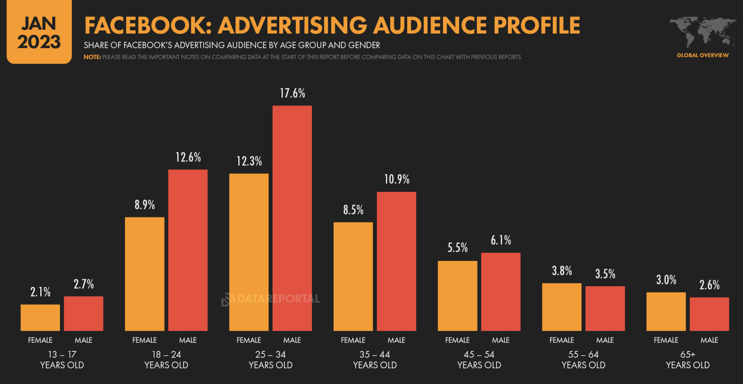

* Age: The majority of people using Facebook are between the ages of 25-34. The median age is 32 years old. 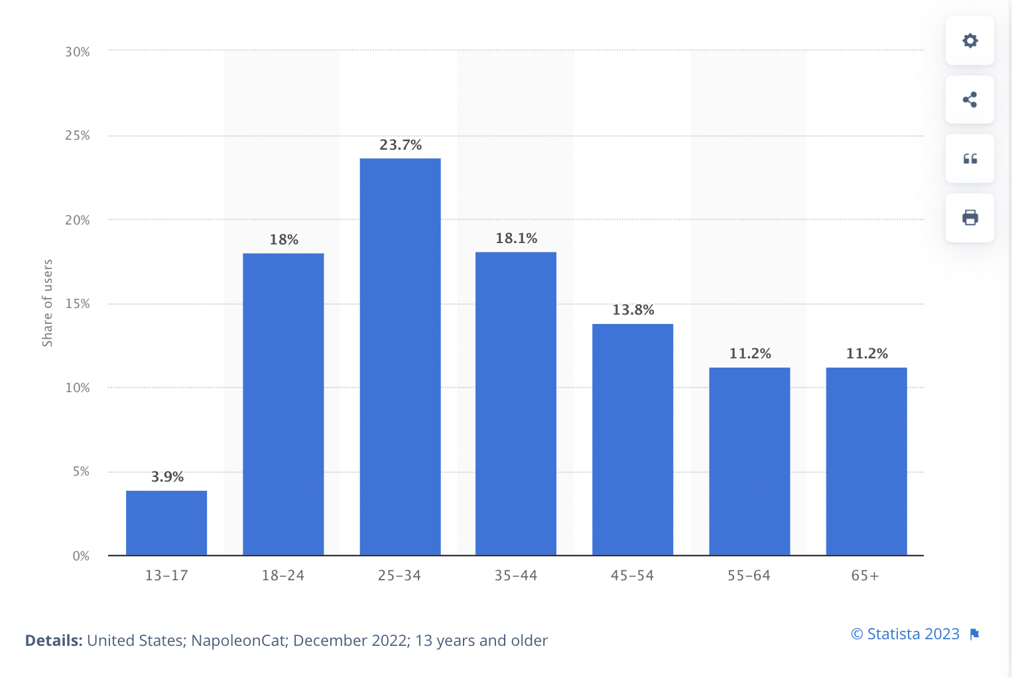
* Gender: 43.7% of overall Facebook’s global users are female, 56.3% of Facebook’s global users are male
* Education: 62% of Facebook users have some form of university education, while 30% report high school as being the highest level of education reached.
* Income: evenly distributed as the graph shown

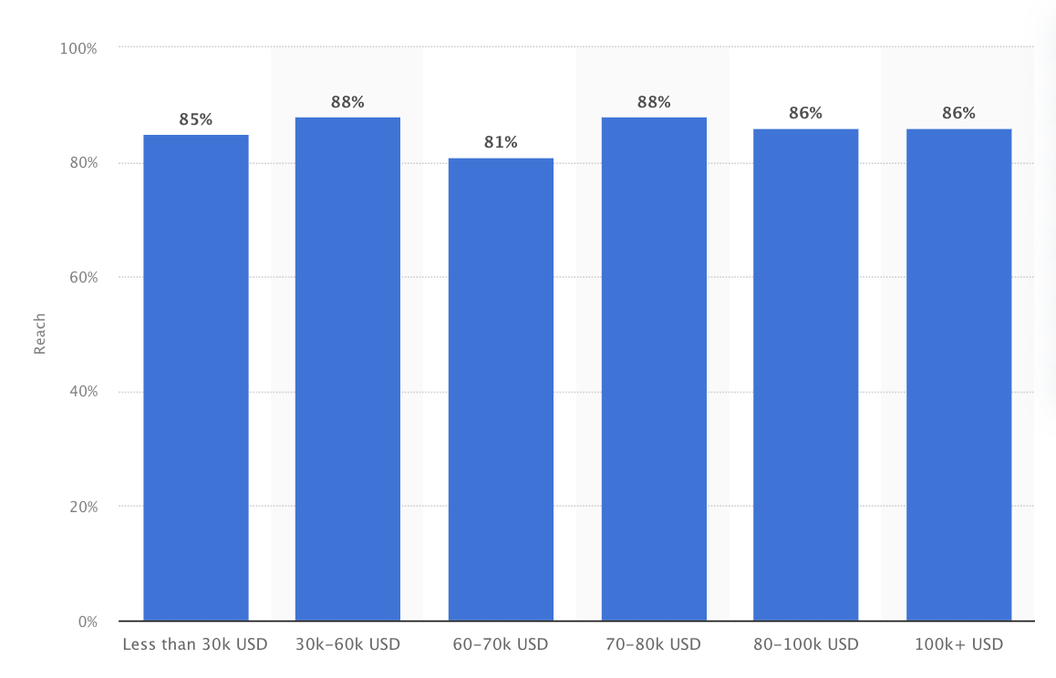

**Communities:**

Facebook Pages:

* LEGO - 14M likes
* LEGO Marvel Video Game - 984k likes
* LEGO DUPLO - 738k likes
* LEGO Harry Potter - 718k likes
* LEGO DC Game﻿ - 583k likes
* LEGO NINJAGO - 450 likes
* LEGO Technic - 340k likes
* The Brothers Brick - 293k likes (source of LEGO news, reviews, fan creations)
* LEGO Ideas - 216k likes
* Lego Star Wars Builders Gather - 33k likes

Groups on Facebook:

* LEGO Technic. - 214k members
* Lego WANTED buy, sell, trade - 139k members
* Lego - Biggest Fans - 112k members
* Lego ~ Sell it, Want it, Swap it!! - 97k members
* Lego Adults Only - 70k members
* LEGO MOC Worldwide - 64k members
* Lego Guides and instructions - 55k members
* LEGO SHOWOFF - 49k members
* Lego Cities - 41k members
* LEGO Star Wars Fans - 38k members
* LEGO Star Wars Builders Gather - 35k members
* Lego Fan Club - 34k members
* LEGO Castle / Brick Knights Alliance - 34k members
* Lego AFOL MOCs - 30k members
* AFOLs - Adult Fans Of Lego - 28k members

A lot of the groups are private, not much information can be pulled.

There are many groups for buying, selling, trading off lego sets

Also many AFOL/adults only groups

**Facebook engagement statistics:**

* 93% of Social Media Marketers use Facebook Ads
* Facebook mobile users represent 88% of total users
* Photo posts currently hold an estimated 4.36% engagement rate, while status posts hold a current 1.66% engagement rate. However, video content posts hold an estimated 6.04% engagement rate.
* Video content is shared by people more than 89 times more than other types of social media content.
* People watch 85% of Facebook videos without sound: visuals are important to attract viewers.
* Square Facebook videos get, on average, 35% more views than landscape videos.

**Tips:**

* Share user-generated content: Lego could encourage its followers to share pictures and videos of their Lego creations on Facebook and then feature the best ones on its page or group. This would create a sense of community among Lego fans and encourage engagement with the brand.
* Promote new releases: Lego could use Facebook to showcase its latest releases and build excitement around them. (share images and videos of new sets, run contests, and provide sneak peeks)
* Host building challenges: Lego could run building challenges on its Facebook page or group to encourage engagement and creativity among its followers.
* Collaborate with influencers: Lego could partner with influencers who have a strong following on Facebook to showcase its products and reach a wider audience.

<https://adtargeting.io/facebook-ad-targeting/lego>